
Company Name
Company Address
Daily Compressed Gas Cylinder Checklist
Month: Location:
Sl.No | Inspection Description | Do's | Don'ts | Date |  |  |  |  |  |  |  |  |  |  |  |  |  |  |  |  |  |  |  |  |  |  |  |  |  |  |  |  |  |  |  |  | Corrective Action Plan
 |  |  |  | Yes |  | No | 1 | 2 | 3 | 4 | 5 | 6 | 7 | 8 | 9 | 10 | 11 | 12 | 13 | 14 | 15 | 16 | 17 | 18 | 19 | 20 | 21 | 22 | 23 | 24 | 25 | 26 | 27 | 28 | 29 | 30 | Corrective Action Plan
1 | Always Keep the cylinder in Vertical Position with valve top | 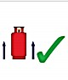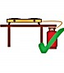 |  | √ | ×
2 | Always install the cylinder at ground level. The LPG appliance should be at a higher level than the cylinder. | 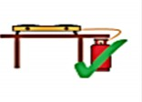 | 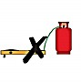 | √ | ×
3 | Retain safety cap with nylon thread attached to cylinder fix the cap on the Valve to stop leak.it any fix the safety cap on the valve in use. |  |  | √ | ×
4 | Ensure that there is adequate ventilation at floor level and at top level. | 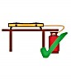 |  | √ | ×
5 | Always use Sulaksha lube and check it regularly for cracks. Change rubber tube at least once in 18 months. |  |  | √ | ×
6 | Do not keep cylinder exposed to sun, Rain, Dust, and heat. | 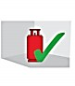 |  | √ | ×
 | Signature
Approved By Reviewed By

